1. **Execute OVER and PARTITION BY Clause in SQL Queries ,creating subtotals &Total Aggregations using SQL Queries.**

**Creating database:**

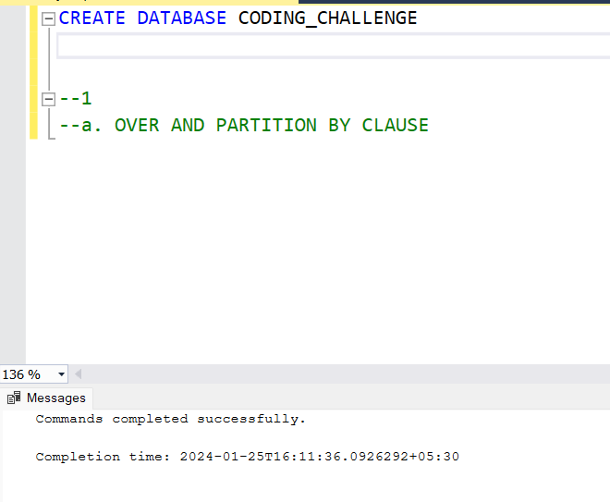

**We used two tables to perform the operations.**

**Creation of table 1 : Department**

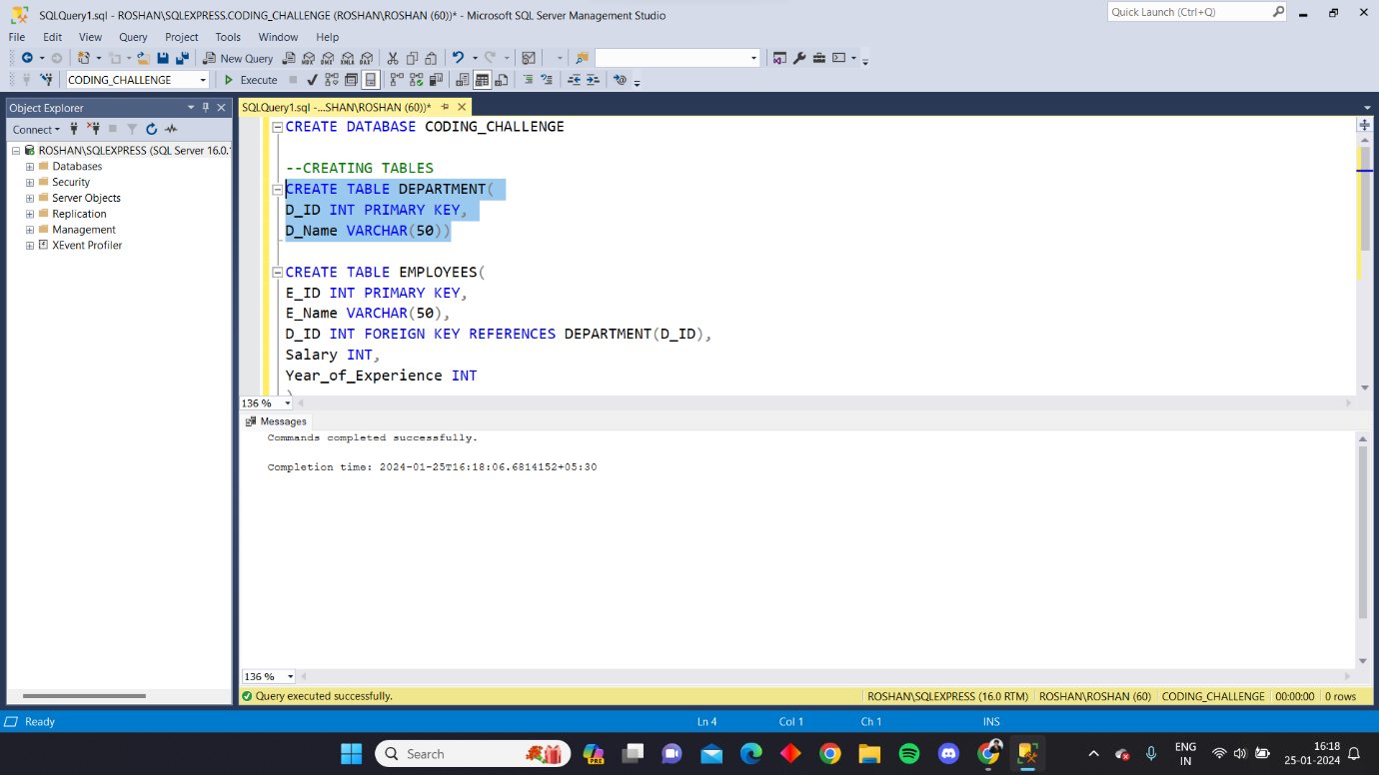

**Creation of table 2: Employees**

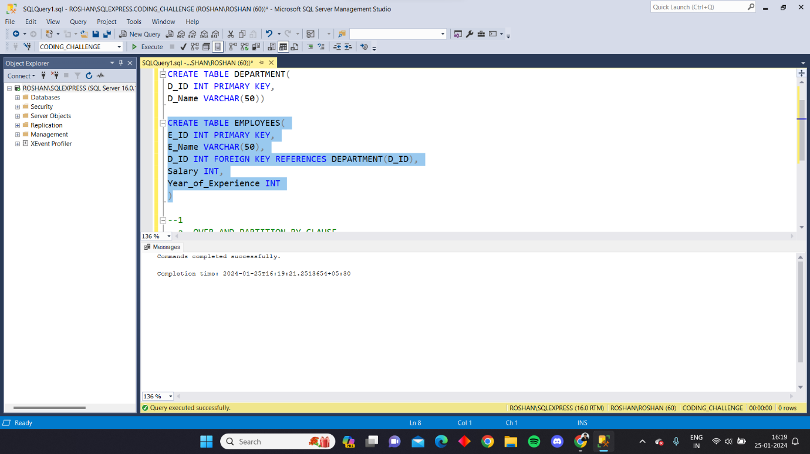

**Inserting data in department:**

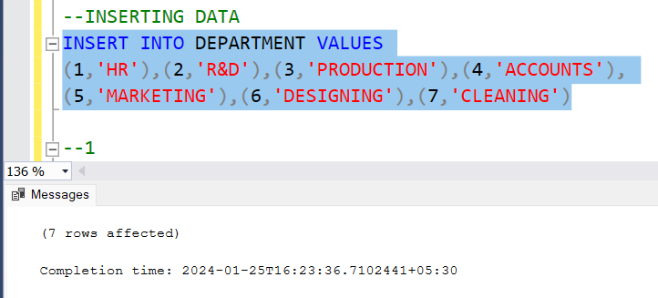

**Inserting data in employees:**

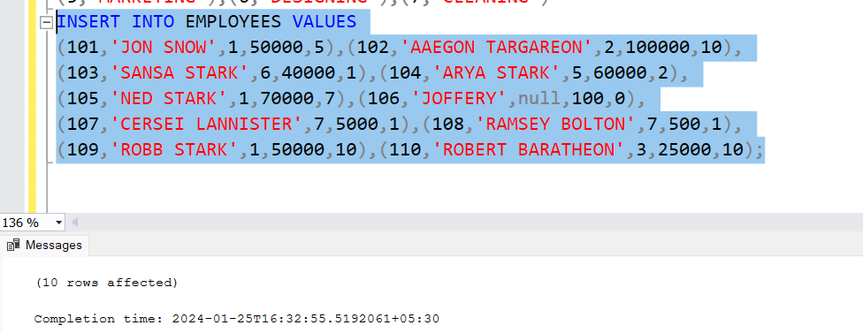

1. **OVER and PARTITION BY :**

The PARTITION BY clause is a subclause to OVER(). It divides the resultant rows into different partitions based on the specified column values. Then the window function is applied to each partition made and gives the results in the form of a separate column.

From the above tables, we chose the E_ID and E_Name from the employees table and by using the PARTITION BY clause we add two more columns OVERALL_AVERAGE_SALARY and AVERAGE_SALARY_BY_DEPARTMENT, without using group by here we used over for the third column to get the total average salary and we used partition by to make partition of data according to their department and calculated the average salary by department.

QUERY:

SELECT E_ID,E_Name,

AVG(Salary) OVER() AS "OVERALL_AVERAGE_SALARY",

AVG(Salary) OVER (PARTITION BY D_ID) AS "AVERAGE_SALARY_BY_DEPARTMENT"

FROM EMPLOYEES

Output:

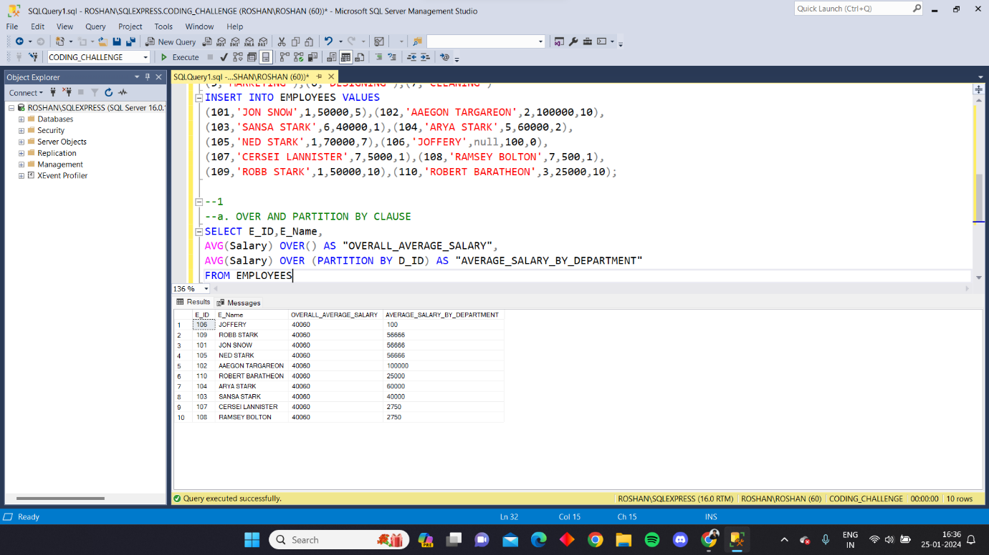

1. **Creating Subtotals:**

We create subtotals of particular data in the output depending on the need. We use ROLLUP clause after the GROUP BY to create subtotals of data.

From the above tables, we calculated the subtotals of salary for each department along with individual employee data using the ROLLUP clause.

**Query:**

SELECT D_ID, E_Name, SUM(Salary) FROM EMPLOYEES

GROUP BY ROLLUP(D_ID,E_Name)

**Output:**

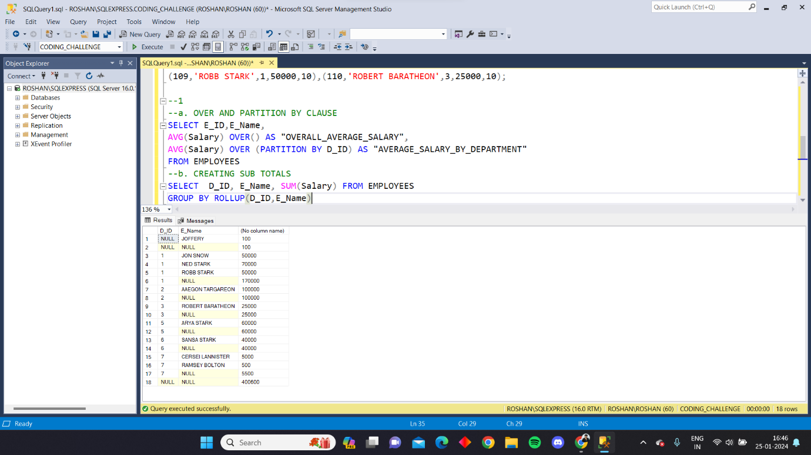

1. **Total aggregations using SQL queries :**

We have five aggregation functions that are used in SQL

1. **COUNT:**

It returns the count of records present in a particular column.

From the above table we calculated the total number of employees present in the employees table.

Query:

SELECT COUNT(E_ID) AS TOTAL_EMPLOYEES FROM EMPLOYEES

Output:

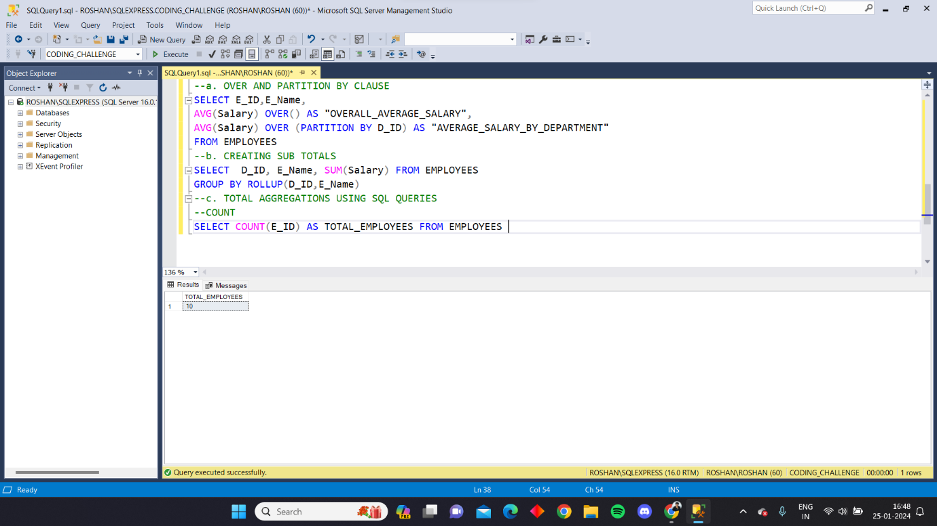

1. **SUM:**

It returns the total of all the data present in all the records.

From the above table we calculated the total salary coming out from each department.

Query:

SELECT D_ID,SUM(Salary) FROM EMPLOYEES

GROUP BY D_ID

Output:

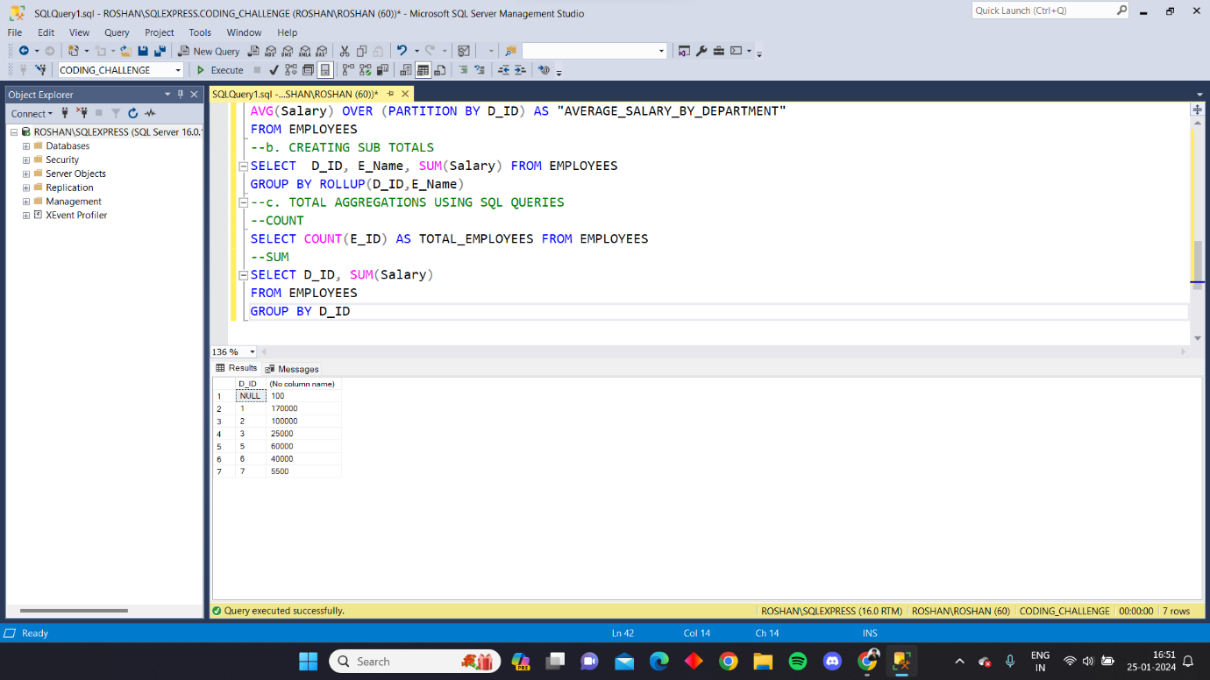

1. **AVG:**

It returns the average value of the data in the records accordingly.

From the above table, we calculated the average salary of each department.

Query:

SELECT D_ID,AVG(Salary) FROM EMPLOYEES

GROUP BY D_ID

Output:

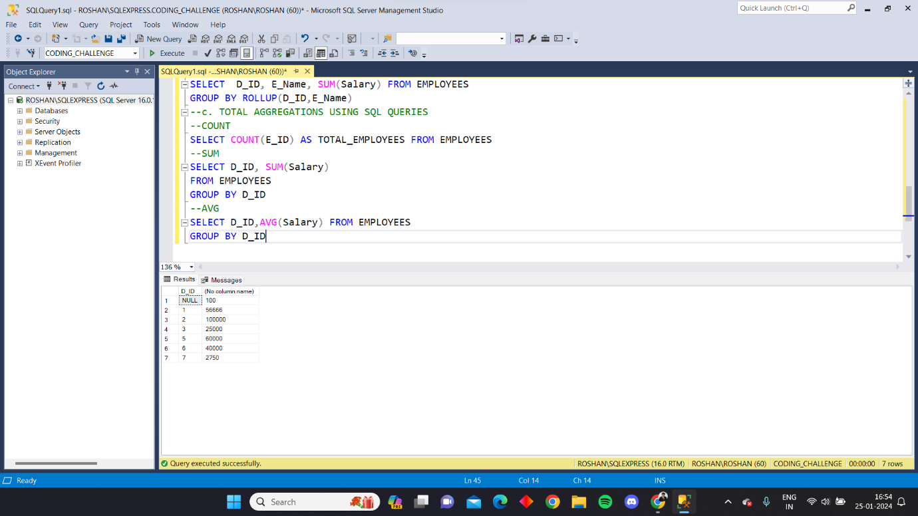

1. **MAX:**

It returns the maximum value from the data provided.

From the above table we calculated the max salary in the department by using the MAX function.

Query:

SELECT D_ID,MAX(Salary) AS MAX_SALARY_BY_DEPARTMENT

FROM EMPLOYEES

GROUP BY D_ID

Output:

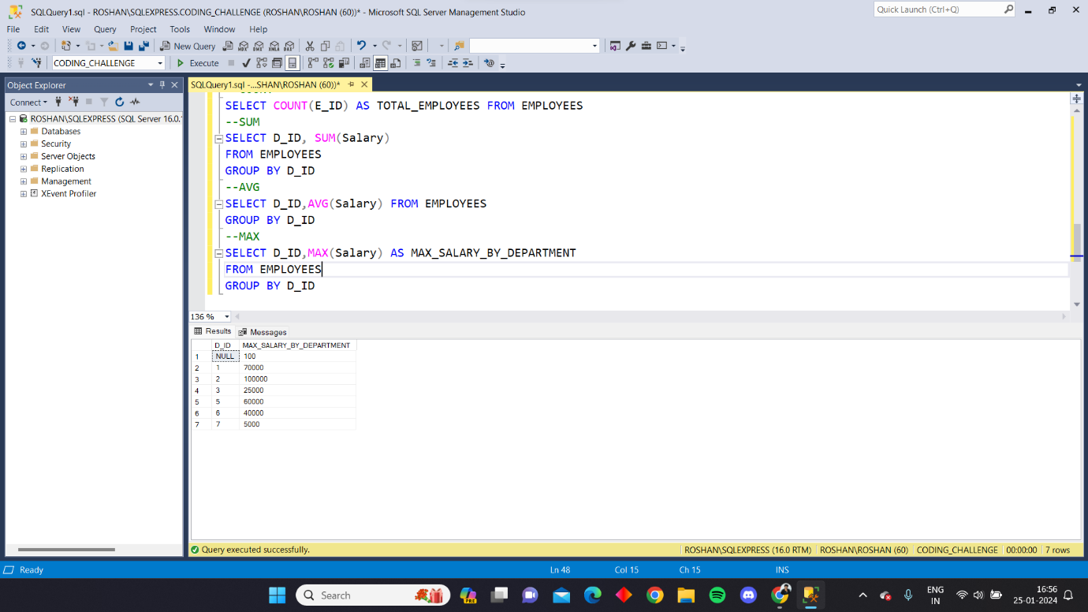

1. **MIN:**

It returns the minimum value from the data provided.

From the above table we calculated the minimun salary in the department by using the MIN function.

Query:

SELECT D_ID,MIN(Salary) AS MAX_SALARY_BY_DEPARTMENT

FROM EMPLOYEES

GROUP BY D_ID

Output:

